Local Search
Students
- Patrick Molina, 157419
- Chihabeddine Zitouni, 158753

Code Repository
https://github.com/patrickmolina1/Evolutionary-Computation

Problem Description
The task is to select a subset of nodes and form an optimal Hamiltonian cycle minimizing the total cost and travel distance. Each node is defined by three attributes: x-coordinate, y-coordinate, and cost. Exactly 50% of the nodes must be selected (rounded up if the total number is odd). The goal is to minimize the sum of the cycle length and the total cost of the selected nodes. Distances between nodes are computed using the Euclidean distance, rounded to the nearest integer. A distance matrix is precomputed after reading each instance and used throughout the optimization process, allowing instances to be represented solely by distance values

Methods
- Greed Local Search
  - 2-node + inter, random start
  - 2-edge + inter, random start
  - 2-node + inter, greedy start
  - 2-edge + inter, greedy start

- Steepest Local Search
  - 2-node + inter, random start
  - 2-edge + inter, random start
  - 2-node + inter, greedy start
  - 2-edge + inter, greedy start

Computational experiment

CPU Specs
AMD Ryzen 7 5800H with Radeon Graphics
Cores | Threads | Clockspeed | Turbo Speed
8 | 16 | 3.2 GHz | 4.4 GHz

Type of Randomization
The greedy local search uses a multi-level randomization approach:
- Move type randomization: Each iteration randomly decides whether to try intra-route or inter-route moves first (50/50 probability).
- Position-based randomization for intra-route moves: All position indices are shuffled before generating move pairs.
- Node-based randomization for inter-route moves: Both the list of selected nodes and non-selected nodes are independently shuffled before evaluating exchanges.
- First-improvement strategy: The algorithm evaluates moves in the randomized order and immediately applies the first improving move found, minimizing the number of evaluated moves

Pseudocode
Algorithm: Greedy Local Search
Input: instance, startingSolutionType, intraRouteMoveType
Output: solution

- Generate starting solution based on startingSolutionType
- Initialize selectedNodes, cycle, selectedIds from starting solution
- Initialize currentCost, currentDistance from starting solution
- Set improved ← true
- While improved:
  - Set improved ← false
  - Randomly decide tryIntraFirst
  - If tryIntraFirst:
    - improved ← tryIntraRouteMove(instance, cycle, intraRouteMoveType)
    - If improved:
    - Recalculate currentDistance and currentCost
    - Continue to step 5
  - interResult ← tryInterRouteMove(instance, cycle, selectedNodes, selectedIds)
  - If interResult.improved:
    - Set improved ← true
    - Update currentDistance += interResult.distanceDelta
    - Update currentCost += interResult.totalDelta
    - Continue to step 5
  - If NOT tryIntraFirst:
    - improved ← tryIntraRouteMove(instance, cycle, intraRouteMoveType)
    - If improved: - Recalculate currentDistance and currentCost
- Return solution with final selectedNodes, cycle, costs

Algorithm: Steepest Local Search
Input: instance, startingSolutionType, intraRouteMoveType
Output: solution

- Generate starting solution based on startingSolutionType
- Initialize selectedNodes, cycle, selectedIds from starting solution
- Initialize currentCost, currentDistance from starting solution
- Set improved ← true
- While improved:
  - Set improved ← false
  - Initialize bestDelta ← 0, bestMoveType ← null, bestMove ← null
  - Generate all possible intra-route moves
  - For each intraMove:
    - delta ← calculateIntraDelta(instance, cycle, move, moveType)
    - If delta < bestDelta:
    - bestDelta ← delta
    - bestMoveType ← "INTRA"
    - bestMove ← move
  - Generate all possible inter-route moves
  - For each interMove (selectedNodeId, nonSelectedNodeId):
    - deltaResult ← calculateInterDeltaDetailed(...)
    - If deltaResult.totalDelta < bestDelta:
    - bestDelta ← deltaResult.totalDelta
    - bestDistanceDelta ← deltaResult.distanceDelta
    - bestMoveType ← "INTER"
    - bestMove ← move
  - If bestDelta < 0:
    - Set improved ← true
    - If bestMoveType = "INTRA":
    - applyIntraMove(cycle, bestMove, intraRouteMoveType)
    - Update currentDistance and currentCost by bestDelta
    - Else (bestMoveType = "INTER"):
    - applyInterMove(...)
    - Update currentDistance by bestDistanceDelta
    - Update currentCost by bestDelta
- Return solution with final selectedNodes, cycle, costs

Function: tryIntraRouteMove
Input: instance, cycle, intraRouteMoveType
Output: boolean (true if improvement found)

- Generate shuffled list of all cycle positions
- For each pair of positions (i, j) where i < j:
  - If moveType = EDGE_EXCHANGE:
    - Skip if positions are invalid (too close or wrapping)
  - delta ← calculateIntraDelta(instance, cycle, [i,j], moveType)
  - If delta < 0:
    - applyIntraMove(cycle, [i,j], moveType)
    - Return true
- Return false

Function: tryInterRouteMove
Input: instance, cycle, selectedNodes, selectedIds
Output: MoveResult(improved, totalDelta, distanceDelta)

- Create shuffled list of selectedIds
- Create shuffled list of nonSelectedIds (all nodes not in selectedIds)
- For each selectedNodeId in shuffled selected list:
- For each nonSelectedNodeId in shuffled non-selected list:
- deltaResult ← calculateInterDeltaDetailed(...)
- If deltaResult.totalDelta < 0:
    - applyInterMove(...)
    - Return MoveResult(true, deltaResult.totalDelta, deltaResult.distanceDelta)
- Return MoveResult(false, 0, 0)

Function: calculateNodeExchangeDelta
Input: instance, cycle, pos1, pos2
Output: delta (cost change)

- Get node1 ← cycle[pos1], node2 ← cycle[pos2]
- Get neighbors: prev1, next1, prev2, next2 (with wraparound)
- If nodes are adjacent:
- Calculate oldCost of current three-edge segment
- Calculate newCost after swapping adjacent nodes
- Return newCost - oldCost
- Else (non-adjacent):
- oldCost ← distance(prev1, node1) + distance(node1, next1) + distance(prev2, node2) + distance(node2, next2)
- newCost ← distance(prev1, node2) + distance(node2, next1) + distance(prev2, node1) + distance(node1, next2)
- Return newCost – oldCost

Function: calculateEdgeExchangeDelta
Input: instance, cycle, i, j
Output: delta (cost change)

- Get four nodes: node1 ← cycle[i], node2 ← cycle[i+1], node3 ← cycle[j], node4 ← cycle[j+1]
- oldCost ← distance(node1, node2) + distance(node3, node4)
- newCost ← distance(node1, node3) + distance(node2, node4)
- Return newCost – oldCost

Function: calculateInterDeltaDetailed
Input: instance, cycle, selectedNodes, selectedNodeId, nonSelectedNodeId
Output: DeltaResult(totalDelta, distanceDelta)

- Find pos ← position of selectedNodeId in cycle
- If pos not found, return DeltaResult(∞, 0)
- Get prev ← cycle[pos-1], next ← cycle[pos+1] (with wraparound)
- Find selectedNode and nonSelectedNode objects
- If either node not found, return DeltaResult(∞, 0)
- costDelta ← nonSelectedNode.cost - selectedNode.cost
- oldDistance ← distance(prev, selectedNodeId) + distance(selectedNodeId, next)
- newDistance ← distance(prev, nonSelectedNodeId) + distance(nonSelectedNodeId, next)
- distanceDelta ← newDistance – oldDistance
- Return DeltaResult(costDelta + distanceDelta, distanceDelta)

Function: applyIntraMove
Input: cycle, move[i,j], moveType
Output: void (modifies cycle in-place)

- If moveType = NODE_EXCHANGE:
- Swap cycle[i] and cycle[j]
- Else (moveType = EDGE_EXCHANGE):
- Reverse segment of cycle from position (i+1) to position j
- Handle wraparound if necessary

Function: applyInterMove
Input: instance, selectedNodes, cycle, selectedIds, selectedNodeId, nonSelectedNodeId
Output: void (modifies data structures in-place)

- Find pos ← position of selectedNodeId in cycle
- Set cycle[pos] ← nonSelectedNodeId
- Find nonSelectedNode object from instance.nodes
- Find and replace selectedNode with nonSelectedNode in selectedNodes list
- Update selectedIds set:
- Remove selectedNodeId
- Add nonSelectedNodeId

Function: generateIntraMoves
Input: cycleSize, moveType
Output: list of all possible moves [i,j]

- Initialize empty moves list
- If moveType = NODE_EXCHANGE:
- For i ← 0 to cycleSize-1:
- For j ← i+1 to cycleSize-1:
    - Add [i,j] to moves
- Else (moveType = EDGE_EXCHANGE):
- For i ← 0 to cycleSize-1:
- For j ← i+2 to cycleSize-1:
    - If NOT (i=0 AND j=cycleSize-1): Add [i,j] to moves
- Return moves

Function: generateInterMoves
Input: instance, selectedIds
Output: list of all possible moves [selectedId, nonSelectedId]

- Initialize empty moves list
- For each selectedId in selectedIds:
- For each node in instance.nodes:
- If node.id NOT in selectedIds:
    - Add [selectedId, node.id] to moves
- Return moves

Results

Method | Instance A | Instance B
GreedyLS_RandomStart_NodeExchange | 93245.75 (85045 - 103817) | 64808.90 (57233 - 72381)
GreedyLS_RandomStart_EdgeExchange | 78703.19 (74582 - 86199) | 51576.83 (48019 - 55971)
GreedyLS_GreedyStart_NodeExchange | 71684.54 (70379 - 72931) | 50045.73 (47460 - 52997)
GreedyLS_GreedyStart_EdgeExchange | 71664.42 (70484 - 72816) | 49901.09 (47140 - 52807)
SteepestLS_RandomStart_NodeExchange | 88108.59 (79789 - 97542) | 62995.08 (55969 - 71020)
SteepestLS_RandomStart_EdgeExchange | 74038.50 (71587 - 77720) | 48372.30 (45719 - 51098)
SteepestLS_GreedyStart_NodeExchange | 71402.91 (70137 - 72931) | 49844.92 (46958 - 52730)
SteepestLS_GreedyStart_EdgeExchange | 71261.04 (69986 - 72711) | 48975.24 (46904 - 51560)

RandomSolution | 264419.52 (230885 - 300429) | 213914.41 (191803 - 235581)
NearestNeighborEndOnly | 103674.65 (90323 - 117672) | 69828.78 (62606 - 77415)
NearestNeighborAllPositions | 72334.99 (71515 - 73823) | 48994.88 (47295 - 51030)
GreedyCycle | 72598.91 (71488 - 74410) | 51532.22 (49001 - 57324)

greedy2RegretNearestNeighbor | 115485.51 (106218 - 122727) | 72981.91 (67809 - 78406)
greedyWeightedRegretNearestNeighbor | 72141.83 (71108 - 73395) | 50627.77 (47144 - 54018)
greedy2RegretGreedyCycle | 116942.80 (110039 - 125138) | 72817.32 (67658 - 77816)
greedyWeightedRegretGreedyCycle | 71888.03 (70700 - 73381) | 50278.91 (47609 - 54296)

Running Times(ms)

Method | Instance A | Instance B
GreedyLS_RandomStart_NodeExchange | 20.27 (10 - 72) | 18.02 (8 - 96)
GreedyLS_RandomStart_EdgeExchange | 24.78 (10 - 54) | 15.25 (7 - 31)
GreedyLS_GreedyStart_NodeExchange | 5.56 (3 - 32) | 6.19 (4 - 33)
GreedyLS_GreedyStart_EdgeExchange | 5.02 (3 - 9) | 5.91 (4 - 14)
SteepestLS_RandomStart_NodeExchange | 257.92 (190 - 419) | 266.45 (183 - 425)
SteepestLS_RandomStart_EdgeExchange | 222.91 (177 - 347) | 228.37 (176 - 376)
SteepestLS_GreedyStart_NodeExchange | 10.39 (0 - 31) | 19.35 (0 - 39)
SteepestLS_GreedyStart_EdgeExchange | 13.29 (0 - 34) | 24.10 (0 - 59)

RandomSolution | 0.06 (0 - 3) | 0.07 (0 - 4)
NearestNeighborEndOnly | 0.25 (0 - 3) | 0.30 (0 - 3)
NearestNeighborAllPositions | 1.78 (0 - 13) | 2.08 (0 - 13)
GreedyCycle | 2.32 (1 - 22) | 2.37 (1 - 23)

greedy2RegretNearestNeighbor | 3.22 (2 - 32) | 3.04 (1 - 30)
greedyWeightedRegretNearestNeighbor | 3.03 (2 - 26) | 2.85 (2 - 27)
greedy2RegretGreedyCycle | 2.97 (1 - 23) | 3.04 (2 - 22)
greedyWeightedRegretGreedyCycle | 2.91 (2 - 22) | 2.90 (2 - 22)

Best Solution

Instance A

GreedyLS_RandomStart_NodeExchang
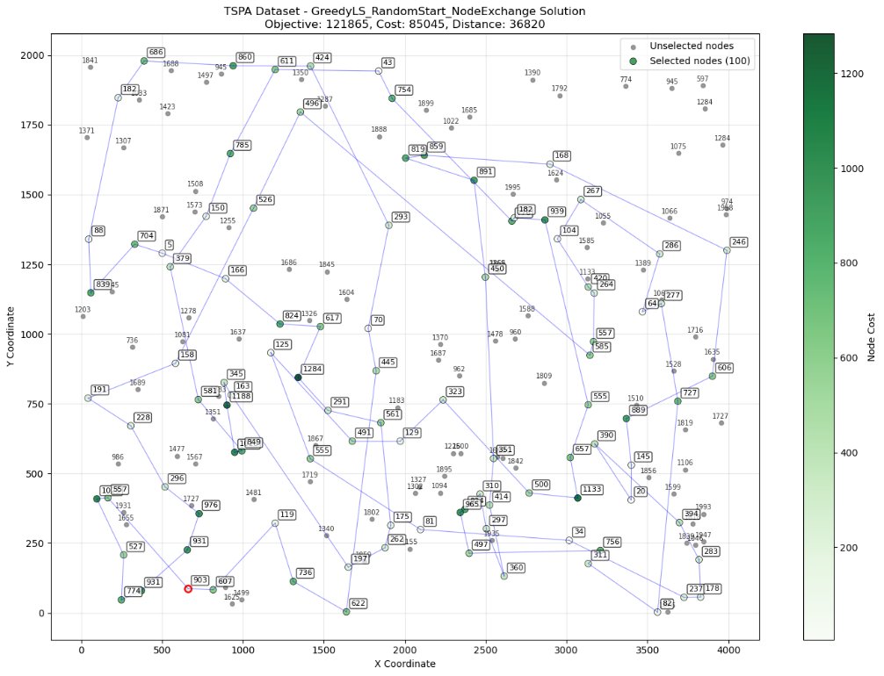

GreedyLS_RandomStart_EdgeExchange
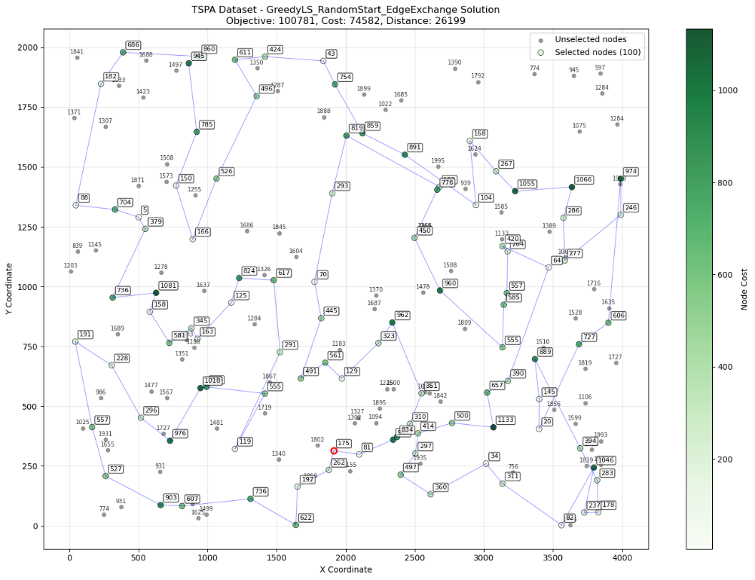

GreedyLS_GreedyStart_NodeExchange
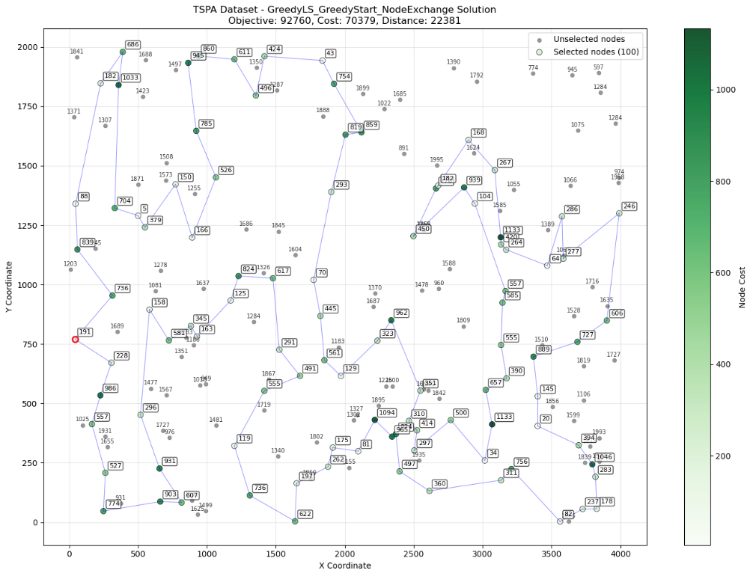

GreedyLS_GreedyStart_EdgeExchange
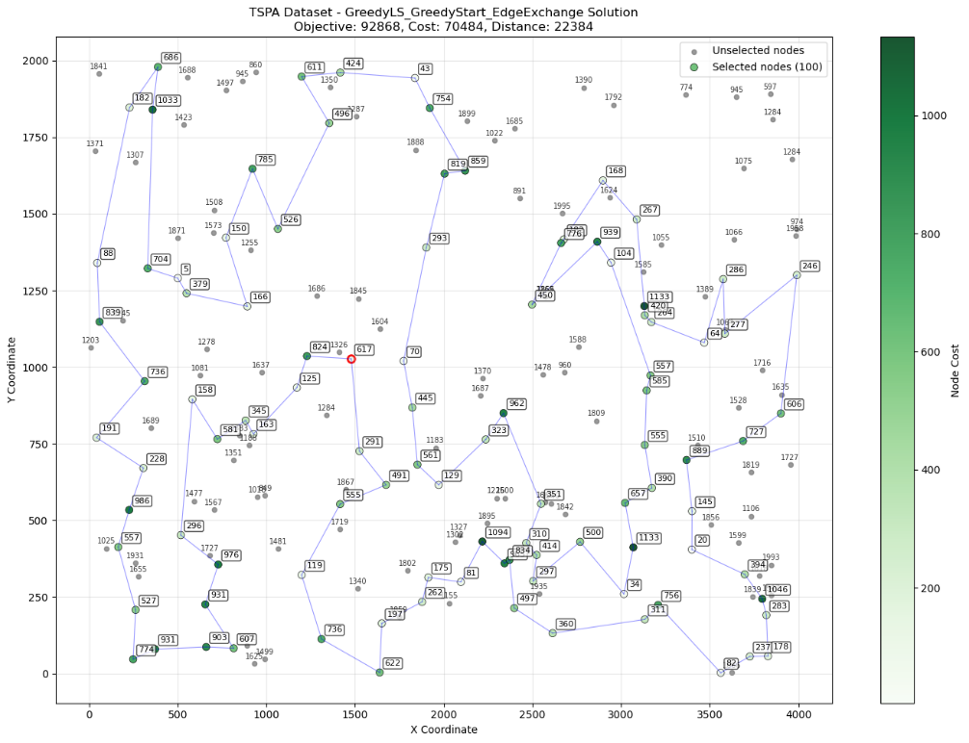

SteepestLS_RandomStart_NodeExchange
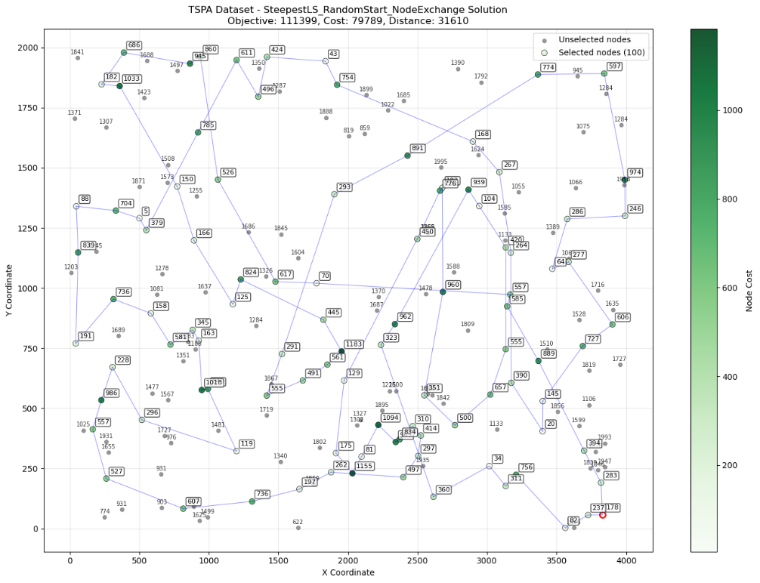

SteepestLS_RandomStart_EdgeExchange
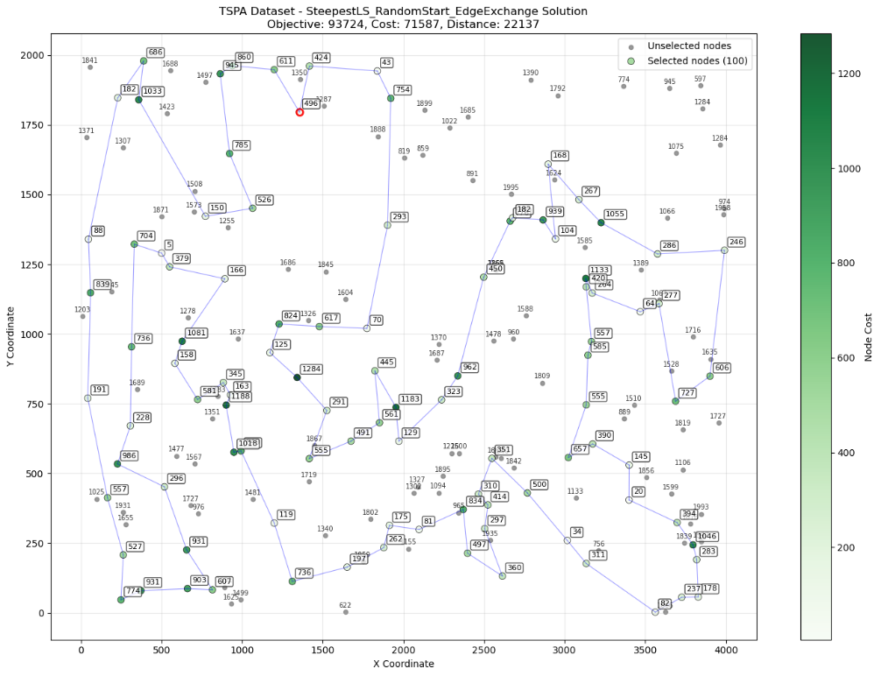

SteepestLS_GreedyStart_NodeExchange
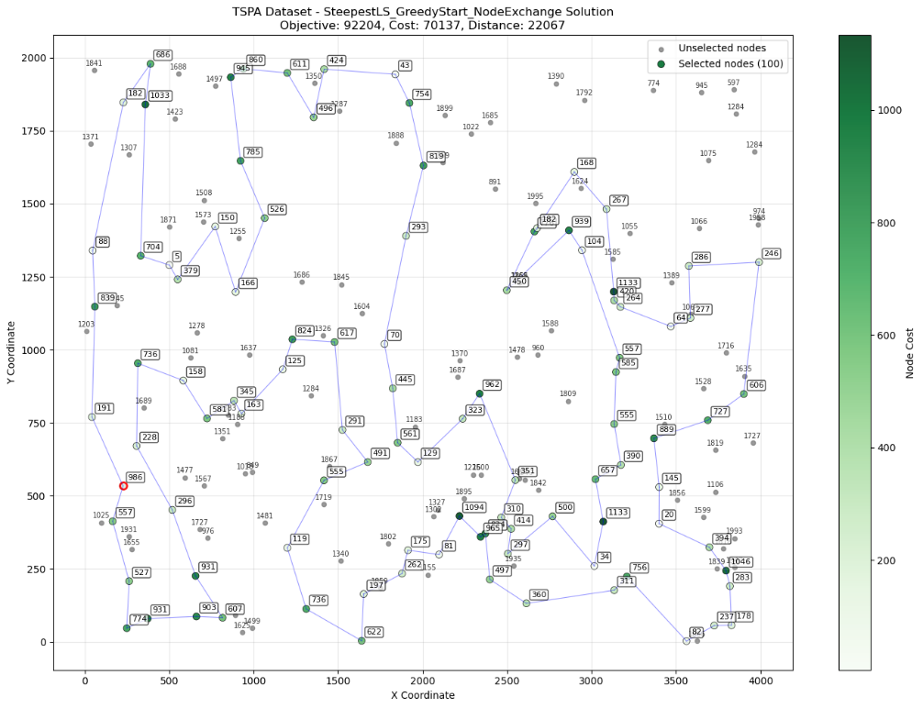

SteepestLS_GreedyStart_EdgeExchange
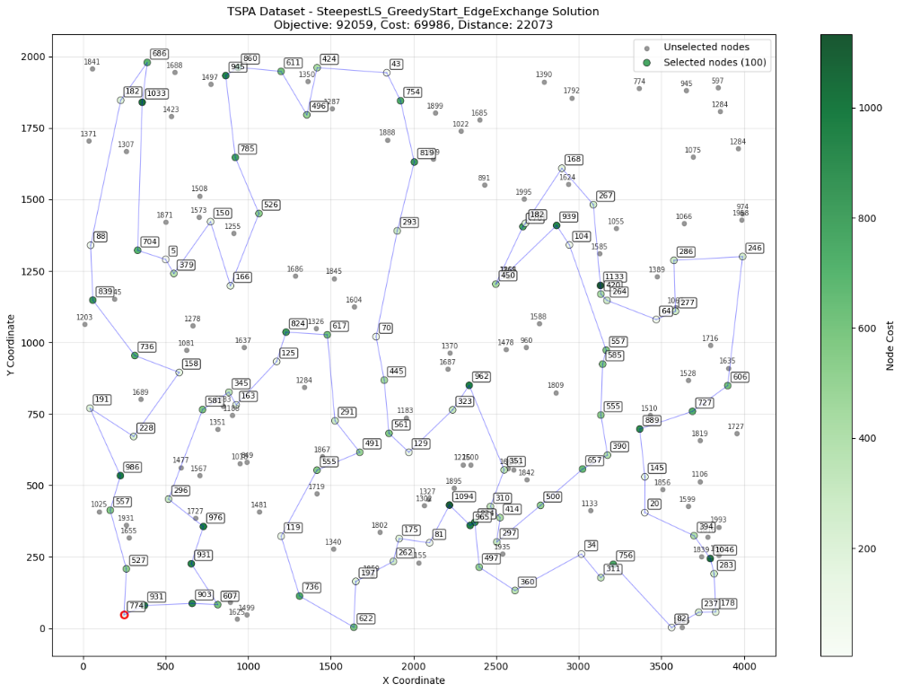

Instance B

GreedyLS_RandomStart_NodeExchang

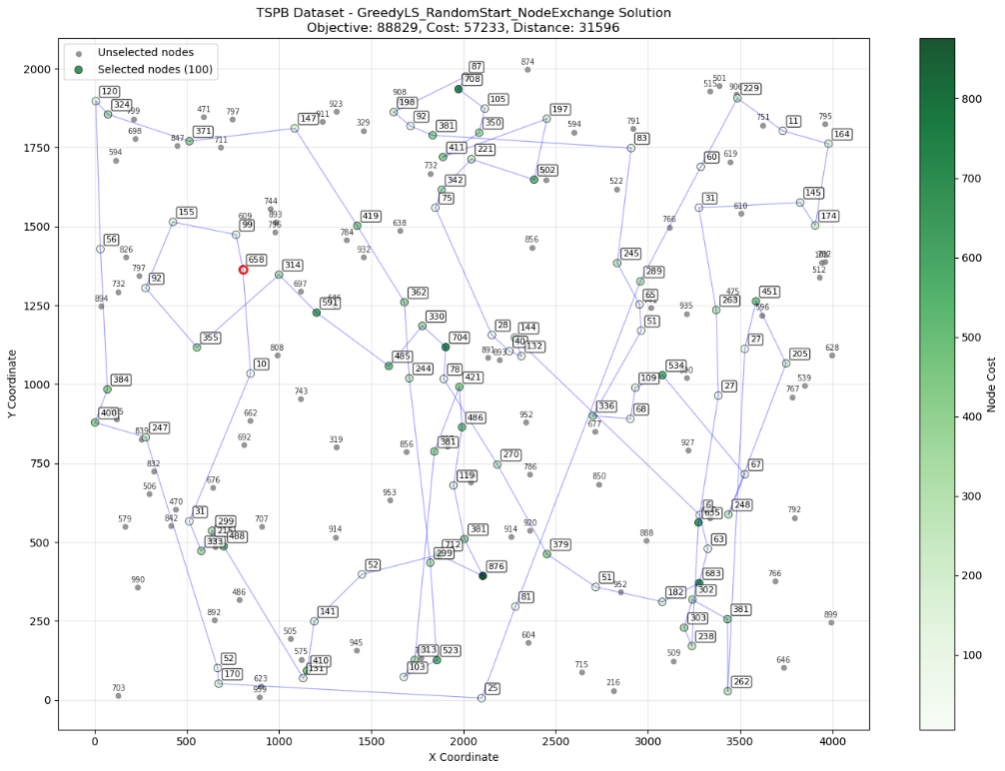

GreedyLS_RandomStart_EdgeExchange
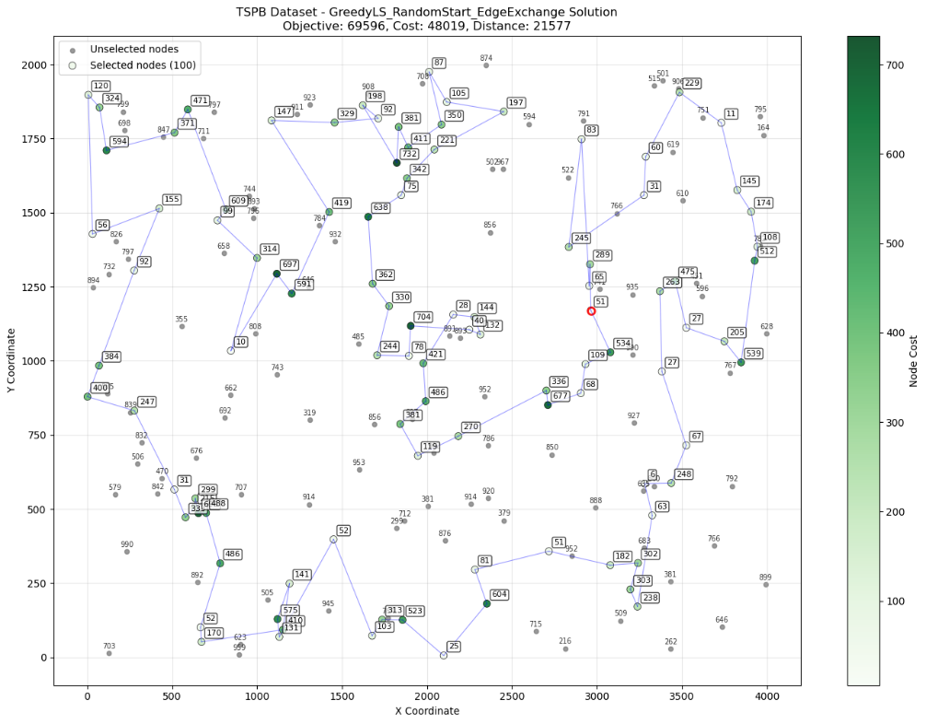

GreedyLS_GreedyStart_NodeExchange

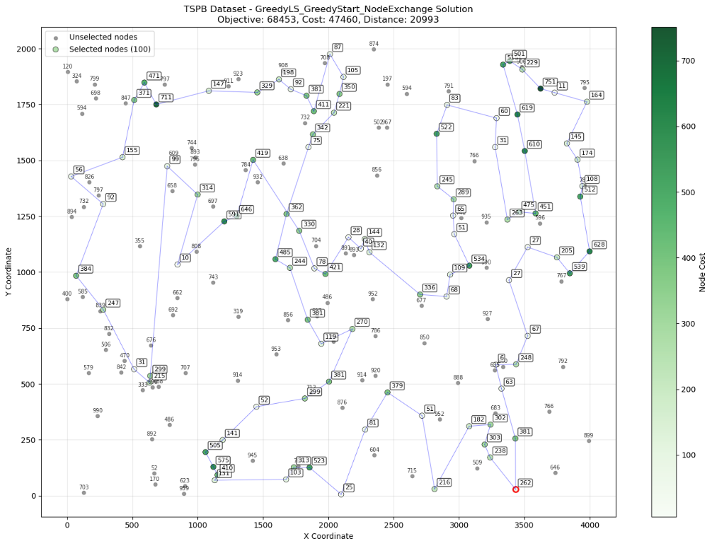

GreedyLS_GreedyStart_EdgeExchange

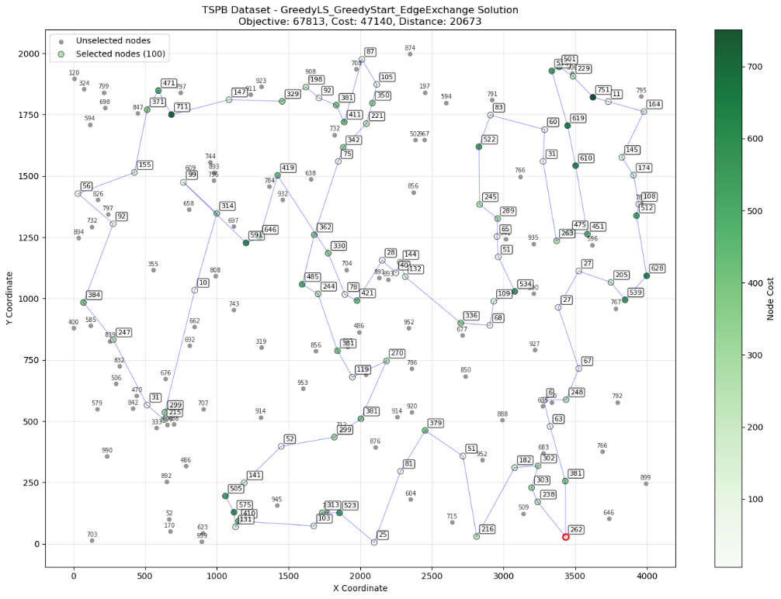

SteepestLS_RandomStart_NodeExchange
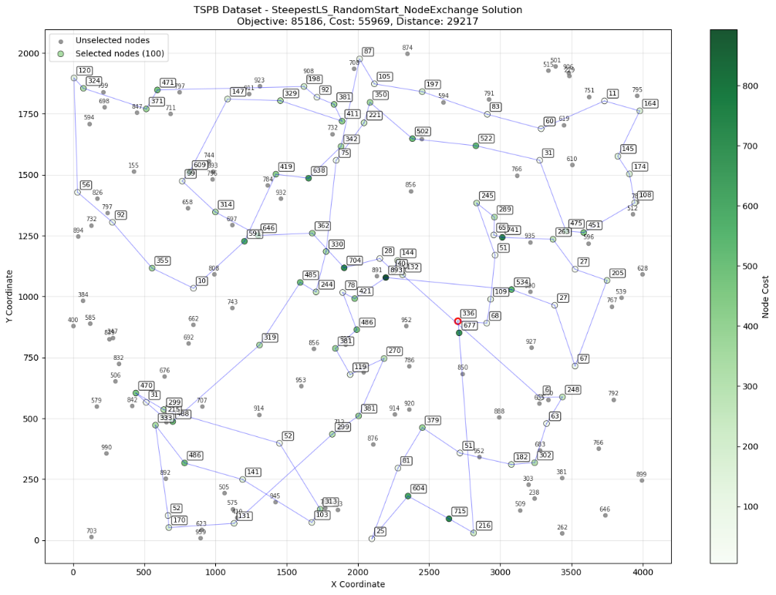

SteepestLS_RandomStart_EdgeExchange
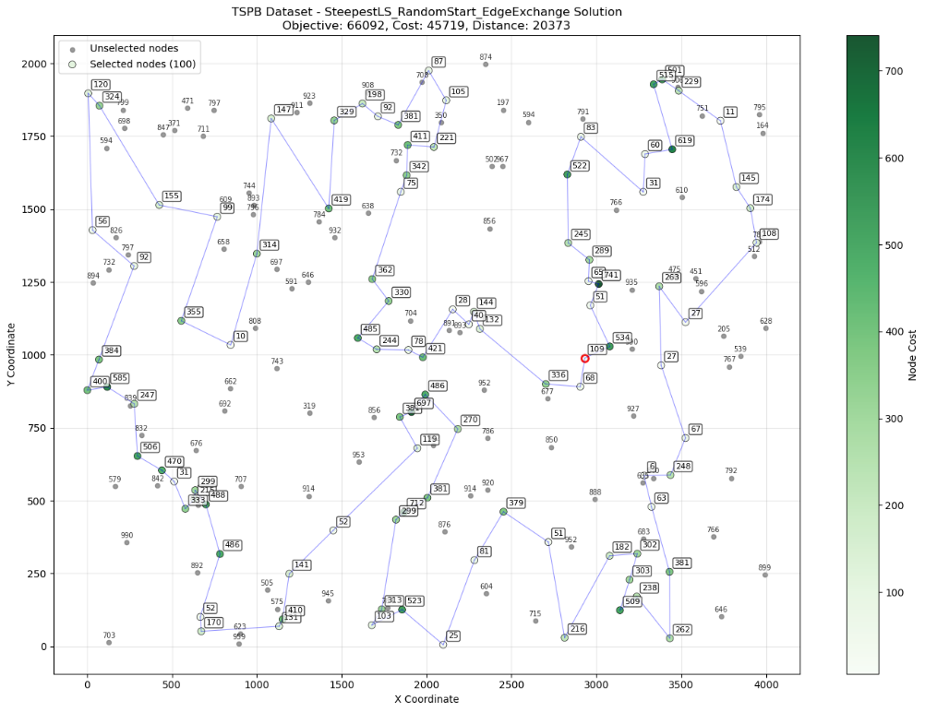

SteepestLS_GreedyStart_NodeExchange

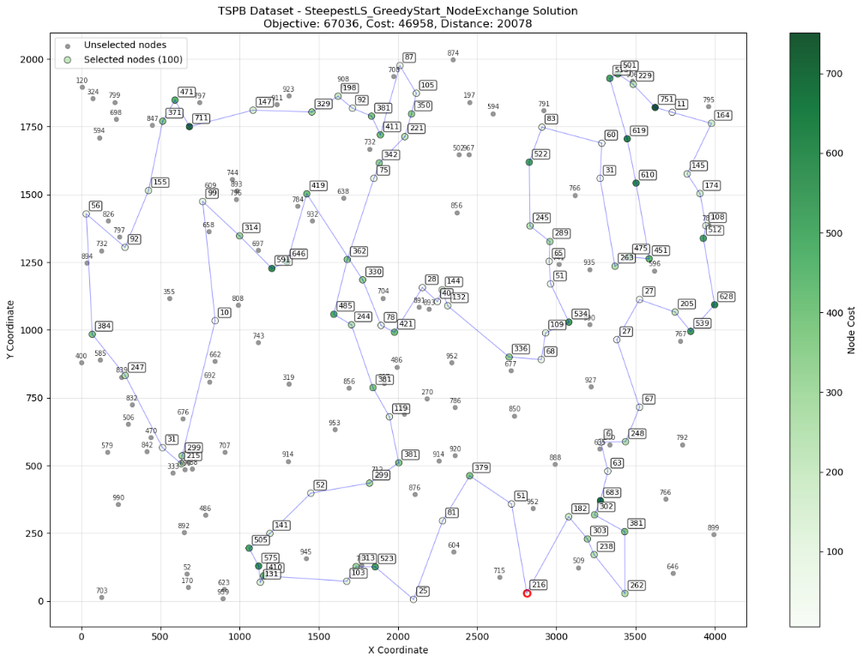

SteepestLS_GreedyStart_EdgeExchange
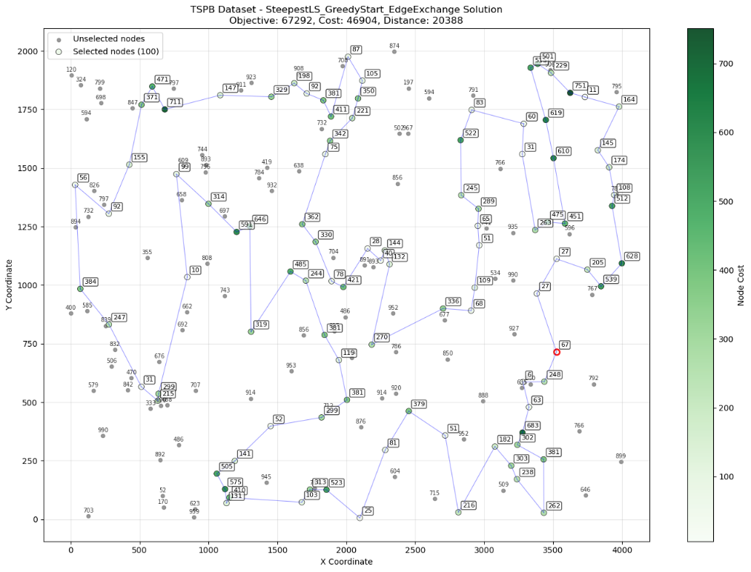

Conclusion
- Greedy-initialized local search clearly outperforms random starts, yielding a 20–30% better objective. Within greedy starts, EdgeExchange beats NodeExchange by 1–2%, and steepest vs. greedy search differences are negligible (<1%). Deltas are used to update the objective for both intra-route (node/edge swaps) and inter-route (selected–unselected exchanges), avoiding full re-computation.
- Greedy local search delivers ~95% of steepest quality at ~40% of the cost, making it the practical choice. Random initialization is inefficient—up to ~50× slower than greedy construction and worse in quality. Use randomized browsing (shuffled intra- and inter-route moves, accept first improvement). Recommended: GreedyWeightedRegretGreedyCycle (2–3 ms) or GreedyLS EdgeExchange for near‑optimal solutions.

